Debugging Log

# Defect Information

**Defect ID:** Bug 3 – Double fine incurred to patron

**Priority:** Major

**Status:** ASSIGNED

**Last updated:** 2020-10-18

**Assigned to:** Sam Johnson

## Reported Issue

When a fine is incurred the amount of fine applied to the patron is double the reported fine.

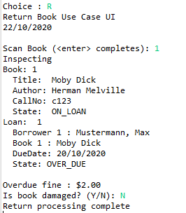

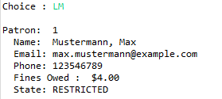

# Replication

## Setup

* Patron created with data as per Test Data
* Patron state is CAN_BORROW
* Patron fines are 0.0
* Book created with data as per Test Data
* Book state is AVAILABLE
* Recorded Patron ID and Book ID

## Tear down

* Remove library.obj file
* Remove calendar.obj file

## Steps

|  |  |  |
| --- | --- | --- |
| **#** | **Test Action** | **Expected Results** |
| 1 | Enter ‘L’ at the main menu, and press Enter | Borrow Book use case UI starts. Prompt to swipe Patron card. |
| 2 | Enter Patron ID, press Enter | Prompted to scan book. |
| 3 | Enter Book ID, press Enter | Prompted to scan another book. |
| 4 | Press Enter | System displays Final Borrowing List. Prompts to Commit Loans. |
| 5 | Enter ‘Y’, press Enter | Completed Borrowing List displayed, prompted to enter any key to exit. |
| 6 | Press Enter | Main menu displayed |
| 7 | Enter ‘T’, press Enter | Prompted to enter the number of days |
| 8 | Enter Number of Days (4), press Enter | Displays new date followed by main menu |
| 9 | Enter ‘R’, press Enter | Return Book use case UI starts. Prompt to scan book. |
| 10 | Enter Book ID, press Enter | Displays inspecting book, book details, and loan details. Prompted to confirm if book is damaged. |
| 11 | Enter ‘N’, press Enter | Main menu is displayed |
| 12 | Enter ‘LM’, press Enter | Patron List is displayed. Bug Evident:  Patron fines are $4.00 when they should be $2.00 |

## Test Data

| **Description** | | **Data** |
| --- | --- | --- |
| Patron 1 | Last name | Mustermann |
| First name | Max |
| Email | max.mustermann@example.com |
| Phone | 123456789 |
| Book 1 | Author | Herman Melville |
| Title | Moby Dick |
| Call Number | c123 |
| Number of Days | | 4 |

# Simplification/Tracing

<List test script actions taken to complete use case>

|  |  |
| --- | --- |
| **Hypothesis #1** | |
| Defect occurs within ReturnBookControl.dischargeLoan() | |
| **Expected State** | **Actual State** |
| Patron finesPayable is 0.0 before and 4.0 after | Patron fines are already 2.0 before and are 4.0 after |
| **Conclusion** | |
| Hypothesis disproven. Defect begins prior to ReturnBookControl.dischargeLoan() as finesPayable has already been set to 2.0 (the correct fine) and then gets increased to 4.0. | |

**Screenshots/Comments:**

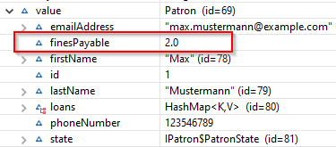

Figure 1: State before Library.dischargeLoan()

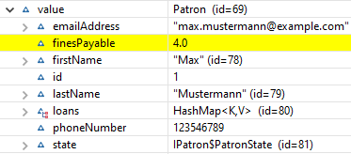

Figure 2: State after Library.dischargeLoan()

Fine appears to be added twice. Once prior to ReturnBookControl.dischargeLoan() and once during.

|  |  |
| --- | --- |
| **Hypothesis #2** | |
| Defect occurs between calls to ReturnBookControl.bookScanned() and ReturnBookControl.dischargeLoan() | |
| **Expected State** | **Actual State** |
| Patron fines Payable is 0.0 before and 4.0 after | FinesPayable is 0.0 before and 4.0 after |
| **Conclusion** | |
| Hypothesis confirmed. | |

**Screenshots/Comments:**

Fines should not be accrued to Patron until the loan is actually discharged. Can write a an automated test that exercises bookScanned() and dischargeLoan(). Test that fines are nil after bookScanned() and correct after dischargeLoan().

Created Automated Test:

returnBookControl_WhenFineIncurred_AccruesCorrectFineToPatron()

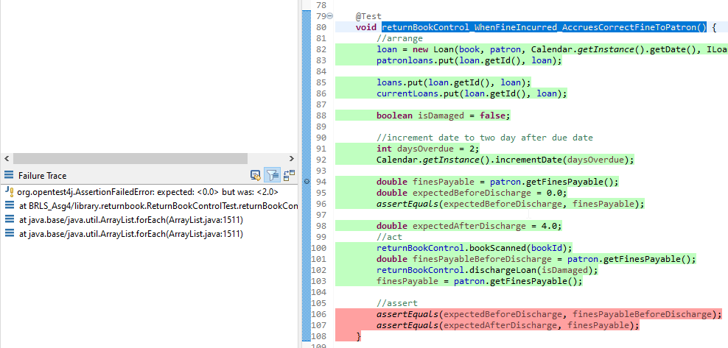

# Resolution

Tracing through ReturnBookControl.bookScanned() reveals that Patron.incurFine() is called. This is also called in dischargeLoan(), thus patron is fined twice.

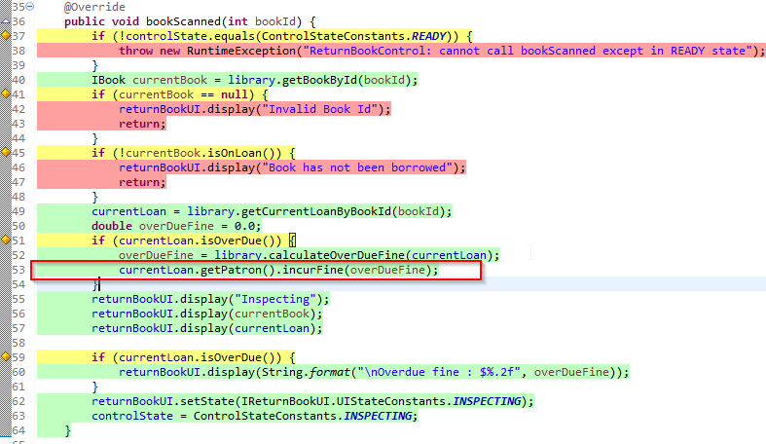

Patron should only be fined when loan is discharged. To rectify the defect, remove the call to incurFine() at line 53.

# Regression Testing

<Describe regression testing undertaken and anomalous results>